Property Website

**CSE326-INTERNET PROGRAMMING LABORATORY**



**Session:** 2020-21

**Submitted** **to**: **Submitted** **by**:

Shabnam Madam Aryan Maan-26 (11917211)

Sushil Kunwar-08 (11900275)

Nirmal Chhetri-35 (11916329)

**Student Declaration**

This is to declare that this report has been written by us. No part of the report is copied from other sources. All information included from other sources have been duly acknowledged. We aver that if any part of the report is found to be copied, we are shall take full responsibility for it.

Aryan Maan

Roll number:26

Sushil Kunwar

Roll number:08

Nirmal Chhetri

Roll number: 35

Place: Lovely Professional University.

Date:06-04-2020.

**TABLE OF CONTENTS**

**TITLE:** Property website PAGE NO.

**1. Background and objectives of project assigned 1**

1.1 Background 5

1.2 Introduction 5

1.3 Outcome of our project 5

**2. Description of project 6**

2.1 LOGIN PAGE 6

2.2 HOME PAGE 6

2.3 PROPERTY PAGE 6

**3. Technology Used 8**

**5. Role of Responsibility 9**

**6. Conclusion and References 9**

**BONAFIDE CERTIFICATE**

Certified that this project report “Property Website” is the bonafide work of “ Aryan Maan, Sushil Kunwar, and Nirmal Chhetri” Who carried out this project work under my supervision.

Name of supervisor: Shabnam

ID of supervisor:25660

Department of supervisor: Division Of Admission

**1. BACKGROUND AND OBJECTS OF PROJECT ASSIGNED**

**1.1 Background**

As we can see there are many property website like magicbricks, 99acres.com etc; as in this way we have made a property website named “HOMETOWN” for providing user friendly face. In this website users can easily found the property of their choice by seeing the specific details and comforts available and pictures provide an imagination of their new house.

**1.2 Introduction**

In our project, we designed a website of property to buy or rent

Name of the website: “ HOMETOWN ”

Site provides online real-estate service committed to helping user to make wise and profitable decision related to buying properties in India. We will provide a fresh new approach to our esteemed user to search for properties to buy or rent.

**1.3 Outcome of project**

The project is to bring the real estate industry online and enabling real estate industries participants to benefit from the Internet site acts as an interface between individuals brokers and realtors.

* This site provide a user friendly face which help user to easily use and get used to and use of images and different shades make website attractive.
* Large option according to the different location over all India and facilities which are provided help them to choose the property of their own choice.

**2. DESCRIPTION OF PROJECT**

* 1. **Login page**
* At first the user sees a login page and the user has to enter his username and password and just login.
* After entering the details of the user, user has to click on login button then moves to home page which is the master page.

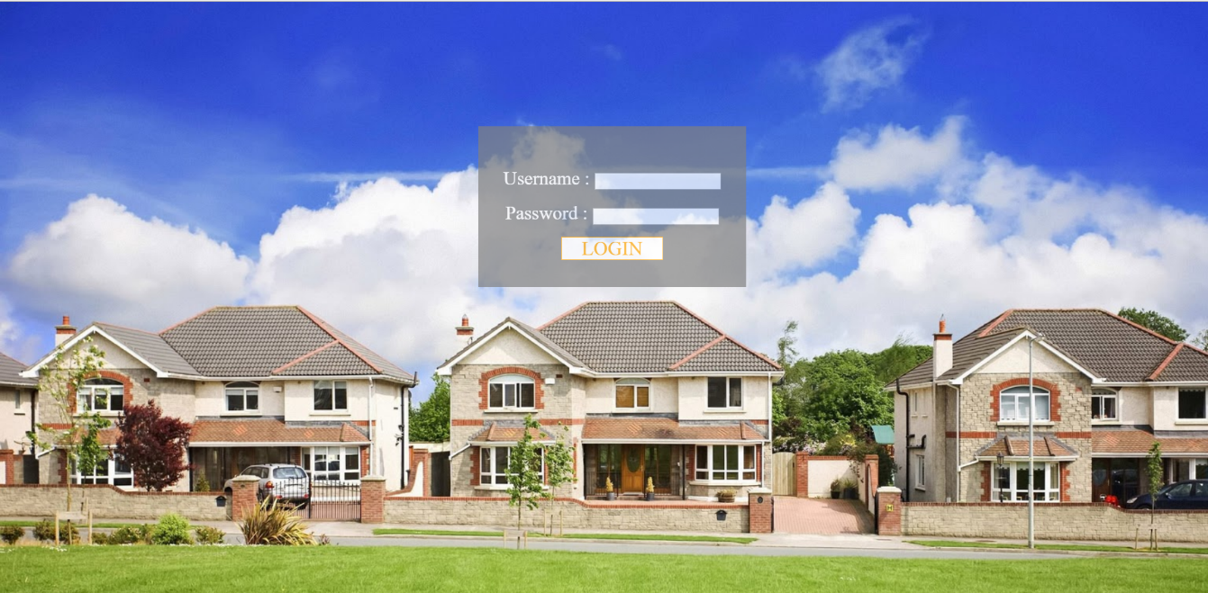

* 1. **Home page**
* In the home page, there will be different pictures and different modules of different properties.
* There is a module name ‘ Top Collection for You ’ in which user get the property according to their search history and location.

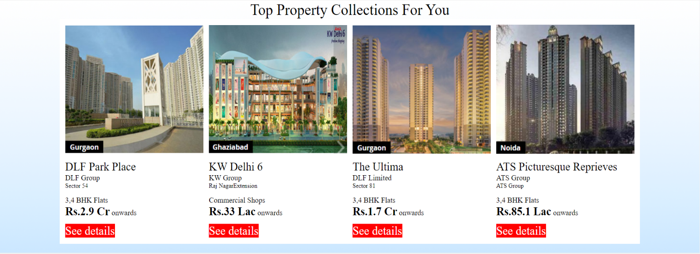

* 1. **Property page**

In this page different specification of property is provided and different module as

* Properties you can buy –

This provide information about apartment or flat like

* Price
* Internal designed map
* No. of BHK

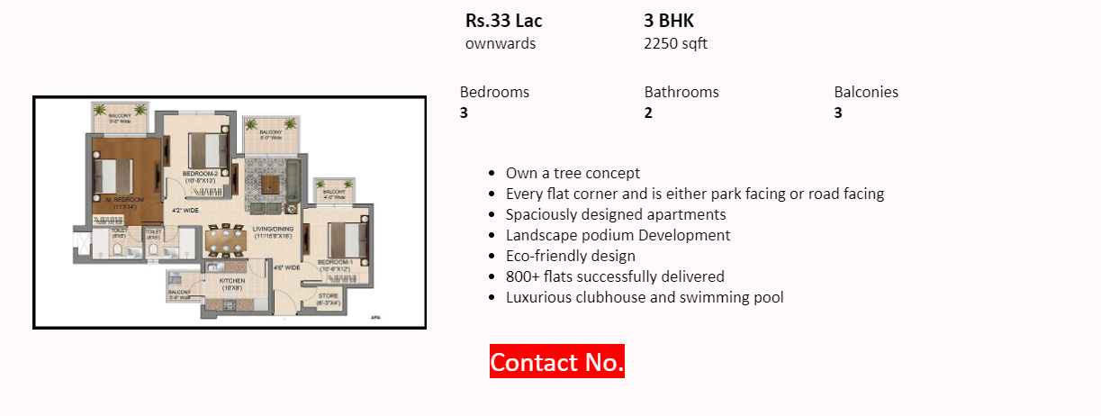

* Facilities you get –

In this module user get information about the facilities which will provide in the house and society.

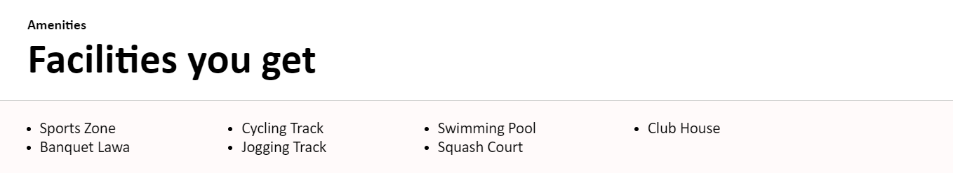

* Take a closer look –

This module provide some pictures of house which make a website attractive and give an imagination view of house.

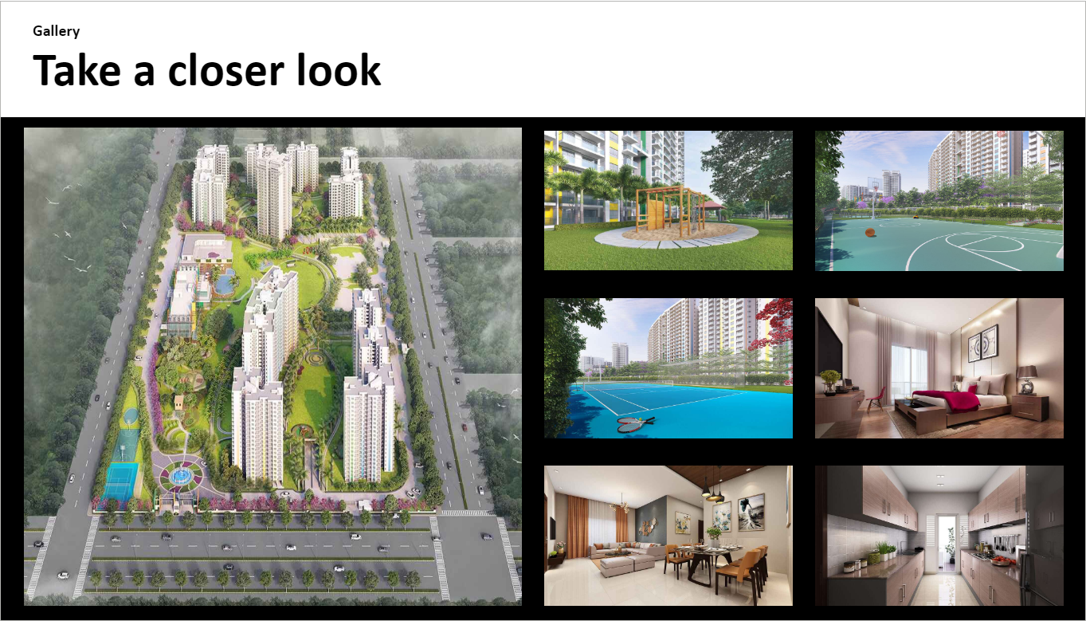

**3. TECHNOLOGY USED**

* In our project, we have used HTML CSS and JAVASCRIPT.
* And we also used many tags, attributes, and elements like position tag and opacity tag.

**4. ROLE OF RESPONSIBLITIES –**

This project was completed with the help of my team with a lot of cooperation and we finished and reported the project on time.

Team members:

* NIRMAL CHHETRI

Worked on the login page and on the main page help in making module of different properties.

* SUSHIL KUNWAR

Worked on the main page and applied CSS in home page for modules and background.

* ARYAN MAAN

Worked on the property page and applied CSS in property page and applied Javascript for pop up box for Contact Builder.

**5. CONCLUSION and REFERENCES**

* By making this website it helps the user to know the best property to buy according their requirements.
* Site provides online real-estate service committed to helping user to make wise and profitable decision related to buying properties in India.
* The project is to bring the real estate industry online and enabling real estate industries participants to benefit from the Internet site acts as an interface between individuals brokers and realtors.
* **REFERENCES:**

Magicbricks.com